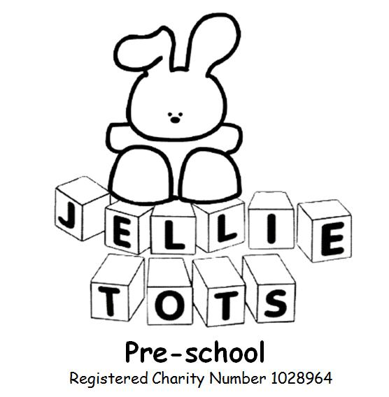

Equal Opportunities Policy
Name of Early Years Setting: Jellie tots Pre-school
Date of written: Oct 2010
Date of next review: Aug 2020

Early years Foundation Stage
General welfare requirement: Safeguarding and promoting children’s welfare.
The provider must take necessary steps to safeguard and promote the welfare of children.
EYFS Principle: A unique child, Inclusive practice.
Outcome: Helping children make a positive contribution to the provision and wider community.

Jellie Tots Pre-school and all staff, volunteers and students are fully committed to valuing diversity by providing equality of opportunity and anti-discriminatory practice for all children and families.

This policy applies to all people, whether using or working within Jellie Tots Pre-school.

We will not discriminate, whether directly or indirectly, in the treatment of any persons on the grounds of gender, race, culture, disability, religion, sexual orientation, marital status or for financial reasons.

Acts of unlawful discrimination will be challenged and the person concerned helped to understand why this is not acceptable.

Jellie Tots Pre-school is open to all members of the community and everyone will be made welcome. Please see our Admissions Policy for our admissions criteria.

In order to promote equality and diversity we will:

- Ensure that all parents are made aware of our equal opportunities policy.
- Offer equality and choice for all.
- Advertise Jellie Tots Pre-school widely.
- Reflect the diversity of members of our society in our publicity and promotional materials.
- Ensure our admissions policy promotes equality for all children and families.
- Not discriminate against a family or prevent entry to our setting, on any grounds.
- Provide opportunities for parents/carers to contribute to their child’s care and education.
- Offer information regarding sources of financial support for families with differing means.

We aim to encourage children to develop positive attitudes about themselves and other people. We will do this by:

- Listening to children to ensure each child feels included, safe, valued and respected.
- Ensuring that all children have equal access to activities resources and learning opportunities.
- Making appropriate provision to ensure each child receives the widest possible opportunity to develop their skills and abilities and recognise different learning styles.
- Providing play materials/resources and activities that demonstrates diversity of background and ability, and help to develop positive attitudes to differences of race, culture, language, gender and ability.
- Promoting children’s awareness of their own culture and beliefs and those of other people.
- Ensuring the differentiation of activities to include the needs of all children.
- Working in partnership with key professionals to ensure that individuals with learning difficulties and/or physical disabilities can participate fully in all aspects of the provision.
- Avoiding stereotypical images in equipment, resources and activities.
- Using positive, non-discriminatory language with all children.
- Ensuring any discriminatory language or practice is challenged appropriately.

English as an Additional Language
- Staff will value linguistic diversity and provide opportunities and support for children to develop and use their home language in their play and learning.
- The setting will provide information in languages which reflect the needs of the local community for families who speak English as an additional language. Our practices will ensure their full inclusion.
- Alongside support in the home language, staff will provide a range of meaning contexts in which children have opportunities to develop English.

Inclusion – please see our Inclusion Policy

Staff Training
- Staff, students and volunteers will be encouraged to attend training opportunities to support their awareness and understanding of equality and diversity.
- Jellie Tots Pre-school SENCO will attend training around special educational needs and the code of practice.
- Staff, students and volunteers will have equal access to identified training to ensure continuing professional development.

Employment Statement – please see our Staffing and Recruitment Policy

Race Equality Statement
- Jellie Tots Pre-school has due regard to eliminate unlawful racial discrimination.
- We promote equality of opportunity and good relations between people of different racial groups.
- We provide good opportunities for children from ethnic minorities and we wish individuals who access our nursery to know that they will receive the same fair treatment and be cared for based on their individual needs.
- All individuals are entitled to equal rights and the same opportunities, regardless of racial group.
- We expect everyone involved in our nursery to seek to eliminate racism where it is identified.
- We strive to ensure equal access to our nursery.
- We encourage, support and help all children and staff to achieve their full potential.
- Our resources will reflect cultural diversity.

This policy also highlights from the Equality Act 2010 the following:

Organisations are prevented from discriminating against people based on their sex, sexual orientation and gender reassignment. Jellie Tots Pre-school has due regard to eliminate discrimination against:

- Children with LGBT families, including same-sex or trans parents.
- Children who do not conform to gender norms.
- Children who are trans or are questioning their gender identity.

Guidance and sources of information:
Race Relations Acts 1976, Amendment 2000 Sex Discrimination Acts 1975, 1986
Education Act 1996 Disability Discrimination Act 1995,2005
Special Educational Needs and Disability Act 2001 Equal Pay Act 1970
Children Act 1989 Equality Act 2006, 2010
Childcare Act 2006

Signed Chair of Management Committee.......................................................................................

