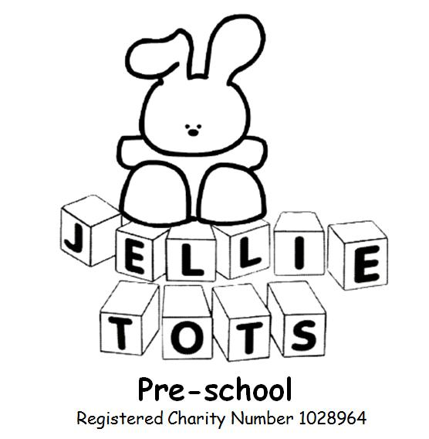

Uncollected Child Policy
Name of Early Years Setting: Jellie tots Pre-school
Date of written: Feb 2006
Date of next review: Aug 2020

Early Years Foundation Stage
General Welfare requirements: Safeguarding and promoting children’s welfare.
The provider must take steps to prevent and promote the welfare of children.
EYFS principles: A Unique Child, Positive Relationships, Enabling Environments.
Outcome: Stay Safe.

We expect children to be picked up at the usual time, if it should not occur we will assume an emergency has caused the delay and will instigate our Uncollected Child Procedure, unless parents/carers let us know they are delayed.

Before children start at Jellie Tots Pre-school we require specific information:

- Home address and telephone number, mobile number of parents.
- Name, home telephone number and mobile number of authorised adults to collect the child from Jellie Tots (e.g. Grandparents, neighbour).
- Password.
- Who has parental responsibility for the child.
- Information about who may not have legal access to the child.

If on occasions parents are aware they are going to be late, they must seek agreement from the manager or key worker before it occurs (in writing). The information will be recorded on the register. Should someone other than the authorised persons be collecting the child we require written consent on our Irregular Collection Form and the manager or key worker must be informed.

Parents of children collected up to 15 minutes later than expected will be reminded of the correct time and asked if there is a genuine reason for the late collection. Parents will be reminded that they should telephone us before the collection time to tell us if they have been delayed. Persistent offenders without genuine reason may incur a financial penalty at the discretion of the Management Committee and/or advised they risk losing their child’s place.

Children collected between 15 and 30 minutes later than expected will wait with two members of staff inside Rivermeads Hall if the next hall user permits. If no permission is given then staff and child will wait outside in the garden area. The person in charge will:

- Call the parents on given contact numbers.
- If no one is available call the additional emergency contact numbers.

Children who are not collected within 30 minutes of the expected time will become the responsibility of the Social Services Department. The person in charge will:

- Call the parents on given contact numbers
- If no one is available they will call the additional emergency contact numbers
- If no one is available they will call Single Point of Access (Tel: 020 8891 7969) and request the collection of the child by the Social Duty Team.
- At all times two members of staff will be present and they and the child will remain on the premises until Social Services collect the child.

The Manager and Chairperson of the Management Committee will review the reasons for the non collection and take action as necessary.

This policy was adopted at a meeting of Jellie Tots Pre-school Management Committee February 2006.

Signed on behalf of Jellie Tots Pre-school ..........................................................Chairperson.

