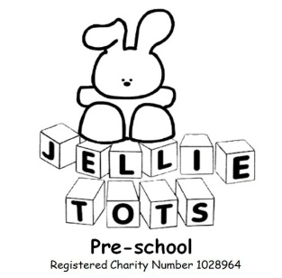

Confidentiality Policy

Name of Early Years Setting: Jellie tots Pre-school
Date of written: Oct 2007
Date of next review: Aug 2020

Early Years Foundation Stage
General Welfare requirement: Safeguarding and promoting children’s welfare. The provider must take the necessary steps to safeguard and promote the welfare of children.
EYFS principles: A Unique Child, Positive Relationships, Enabling Environments.
Outcome: Positive Contribution, Safeguarding, Organisation

Statement

All information on children, families and anyone working in Jellie Tots Pre-school is kept securely and treated in confidence (unless a safeguarding issue). Information will only be shared if the parents, carers/co-workers give their permission or there appears to be a safeguarding-child protection issue. All details are easily accessible if any information is required for an Inspector by Ofsted.

Procedure

All parents are informed of how to access our policies and procedures that detail how Jellie Tots operates.
We comply with the Data Protection Act 1998 and Freedom of Information Act 2000 and are registered with the Information Commissioner. All written records are kept securely locked away and are only accessible to staff who have a right or a professional need to see them.
We maintain a record of parent(s) and for emergency contact details, the contact details of the child’s GP and appropriate signed consent forms.
If a child is identified as a child in need, we will normally with the parent’s permission, give appropriate information to referring agencies such as social services.
Records of observation, assessments and planning are kept for each child to promote their individual development and progress.
We expect parents to inform us of any changes in the child’s home circumstances, care arrangements or any other change that may affect the child’s behaviour.
All information shared will be kept confidential and will not be disclosed without parent(s) consent, except as required by law. Please see our Safeguarding Child Protection Policy and Restrictive Intervention Policy.
Ofsted may request to see the records held at any time.
Parents have the right to inspect all records about their child at any time.
All accidents that happen in the nursery will be recorded in an accident/incident book. All accidents and injuries will be reported to the company providing our public liability insurance. A report to RIDDOR may be required.
When a child arrives at Jellie Tots with pre-existing injuries and marks these will be recorded in our Arrived with Injury book.
All significant incidents are recorded in our accident/incident book and will be shared and discussed with parents so that together we can work to resolve any issues.
If we keep records relating to an individual child on a computer we will ask for parent’s permission. The information will be securely stored to prevent viewing of the information by others with access to the computer. If we use back-up files such as a memory stick we will lock them away securely.

This policy was adopted at a meeting of the Jellie Tots management committee
Held on: Oct 2007

Signed on behalf of Jellie Tots:...........................................................Chairperson

