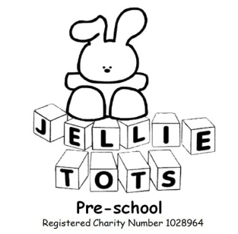

Display Policy

Name of Early Years Setting: Jellie tots Pre-school
Date of written: Nov 2012
Date of next review: Aug 2020

Early Years Foundation Stage
EYFS principle: Enabling environments; 3.3 the learning environment
Outcome: Make a Positive Contribution, Enjoy and Achieve.

Statement of Intent
Our nursery environment reflects the ethos of Jellie Tots Pre-school. Children learn most effectively when engaged in first hand experiences. Displays of natural and man-made objects can provide powerful stimulus for learning. Displays can also help create an interesting and attractive environment in which learning is facilitated; and which can help foster a caring attitude by children to their surroundings. When children’s work is valued by being displayed, their self esteem is built up.

Method
We will ensure that: -

- Displays show children’s achievements and provide information for reference and act as a stimulus for ideas.
- Our environment offers opportunities for learning through displays of resource materials encouraging interaction by the children.
- Children have access to visual resources and reference materials.
- Displays reflect the quality and expectations of our pre-school.
- Displays are appealing and varied. Work showing a variety of techniques and media are displayed.
- Displays comprise the children’s own work and careful consideration given to how work is mounted; choice of background colour and texture and the use of text for providing information.
- Displays are relevant to the work being carried out with the children. Work in progress as well as finished work will be part of displays.
- Displays are representative of all children reflecting the multi cultural society in which we live.
- A range and variety of children’s work are shown.
- Progression throughout the pre-school is reflected in the displays.
- Children are encouraged to make decisions about displays. They are involved in the selection, presentation and mounting of displays.
- Displays are rich in text, this being the means of providing information, posing questions to extend children’s learning.
Guidelines/ good practice

- Provide a short explanation of the task/learning objectives that produce the work.
- Include a variety of two and three dimensional work, paintings, drawings, writing, models etc.
- Draw the children’s attention to the display during work time. Displays should be used positively as a teaching and learning resource. A range of questions to encourage interaction.
- Do not cut children’s work.
- Label children’s work with names on the border if possible.
- Keep displays simple and uncluttered for maximum effect.
- Keep lettering simple, clear and consistent. Use both computer generated and hand written text.
- Consider the children’s eye levels – work should be clearly visible to them.
- Involve the children in planning displays – choosing work, making labels, mounting pictures etc.
- Check spelling.
- Have a clear title.

Types of displays

On walls
On tables/cupboards
Individual books
Low level display boards

This policy was adopted at a meeting held on Wednesday 28th November 2012

Signed on behalf of Jellie Tots Pre-school........................................................................

Chairperson:

